I-20 Certification of Finances 

Prospective F-1 students must have the financial resources to live and study in the United States. This includes being able to cover the cost of tuition, books, and living expenses. Harvard Summer School must collect evidence of the student’s financial ability before issuing a Form I-20 Certificate of Eligibility for Nonimmigrant Student Status. Harvard Summer School students who are not United States citizens or permanent residents must complete and submit this I-20 Certification of Finances Form to the I-20 Document Portal by April 30, 2026. Without complete information and appropriate certification, the I-20 cannot be issued.

STUDENT INFORMATION (Complete the 3 fields below)
Student’s last name
Student’s first name
Student’s HUID or DCE ID

FINANCIAL SPONSOR INFORMATION (Select all that apply) This section below is for you to indicate if:

You will personally pay your cost of attendance.

A friend or family member will pay your cost of attendance.

Your school, company, organization, or government funds will pay your cost of attendance.

Please choose the section(s) below that apply to you. You are required to checkmark each of the boxes as you complete your section(s). ONLY complete the section(s) that apply to you. SKIP the section(s) that do NOT apply to you. You must complete at least one section.

- ☐ Self-sponsored (Checkmark all the following boxes in this section if you are self-sponsored.):
☐ Student Information
☐ Financial Sponsor Information
☐ Declaration of Finances
☐ Declaration of Accuracy

- ☐ Sponsored by a friend or family member (Checkmark all the following boxes in this section if you are sponsored by a friend or family member.):
☐ Student Information
☐ Financial Sponsor Information
☐ Declaration of Finances
☐ Declaration of Accuracy
☐ I-20 Sponsorship Certification page

- ☐ Sponsored by my school, company, organization, or government funds (Checkmark all the following boxes in this section if you are sponsored by your school, company, organization, or government funds):
☐ Student Information
☐ Financial Sponsor Information
☐ Declaration of Finances
☐ Declaration of Accuracy
☐ Have your school, company, organization, or government representative create a letter following the sample provided in the “Example Letter” at the end of this document.

I-20 Certification of Finances

REQUIRED FINANCES
Below are the estimated expenses in US dollars for the 2026 academic sessions at Harvard Summer School. Prospective F-1 students are required to provide evidence of liquid funds to pay for these expenses. Use this table to complete the following pages of this form.

Type of Expense | Seven weeks of study OR both three-week sessions | Three OR four weeks of study
Tuition | $7,960 | $3,980
Room and Board | $8,620 | $4,920
Miscellaneous (Books, Program Fees, Health Insurance, etc.) | $1,000 | $600
Total | $17,580 | $9,500

DECLARATION OF FINANCES
Select the total amount of liquid funds in US dollars you are required to have in the United States. Use the table of estimates above for reference. You must complete each section below; do NOT leave any section blank. You are not expected to pay this exact amount. This amount reflects approximately how much money the United States government expects you to have to support yourself while in the United States. Your actual expenses may be lower.

Select only one option. This is the amount of liquid funds you must have, based on the academic session(s) you are interested in. DO NOT leave this section blank. |  | ☐$17,580  ☐$9,500
 | Are you bringing a dependent? Dependents are unmarried children under age 21 and/or a spouse who will accompany you for the duration of your studies. Students’ parents and domestic partners are ineligible for dependent status. | ☐ No, I am not bringing a dependent and will skip the dependent section below  ☐ Yes, I am bringing a dependent and will complete the dependent section below

DEPENDENT EXPENSES SECTION (SKIP IF YOU DO NOT HAVE ANY DEPENDENTS)
If you are bringing any dependent, you are required to provide proof of liquid funds for the amount declared in “DEPENDENT TABLE TWO” below in addition to your personal academic costs calculated in the previous section. Your supplementary financial documents must show enough liquid funds for your dependents and yourself. To calculate your dependent costs, use the first table below to complete the second table below. The total dependent amount reflects approximately how much money the United States government expects you to have to support your dependents while in the United States. Your actual expenses may be lower.

DEPENDENT TABLE ONE

Additional Costs for Accompanying Dependent(s) | Seven weeks of study OR both three-week sessions | Three OR four weeks of study
One Adult | $2,000 | $1,350
One Child | $1,100 | $750

DEPENDENT TABLE TWO

Type | Number of dependents (write number of dependents you are bringing with you.) | Cost per dependent (see table directly above.) | Subtotal (multiply the number of dependents by their cost.)
Adult |  | $2,000 (6-7 weeks) / $1350 (3-4 weeks)
Child |  | $1,100 (6-7 weeks) / $750 (3-4 weeks)
Total Dependent Expenses | - | -

Example: if you bring 1 adult and 1 child for seven weeks of study,
Adult 1 x $2,000 = $2,000
Child 1 x $1,100 = $1,100
Total dependent expenses = $3,100

Student’s full name

DECLARATION OF ACCURACY
I,
declare that the information reported on this form is true, correct, and complete.

WARNING: Providing false information may result in immigration consequences and may jeopardize enrollment at Harvard Summer School.

Signature of Student ______________________________ Date (mm/dd/yyyy)_____________

Digital signatures are not accepted. Please sign and date with a real signature.

I-20 Sponsorship Certification

STUDENT AND SPONSORSHIP INFORMATION (Complete all the fields below)
Student’s last name
Student’s first name
Student’s HUID or DCE ID
Sponsor’s full name
Sponsor’s relationship to the student
(example: mother, uncle, father, etc.)

This certifies that I,
Sponsor’s full name
am willing and able to financially support the above-named student (and their dependents, if applicable) for academic fees and living expenses in the amount of
USD$
throughout the duration of their studies at Harvard Summer School. This amount should be less than or equal to the “amount of liquid funds” selected in the “DECLARATION OF FINANCES” section plus any applicable dependent costs. Additionally, I am certifying that attached to this document is official documentation of available liquid funds for at least the length of the program of study. The documentation is in English and signed on or after August 1, 2025. It is the student’s responsibility to document availability of additional required funds, if necessary.

Signature of Sponsor ______________________________ Date (mm/dd/yyyy)_____________

Digital signatures are not accepted. This application will be considered incomplete without the sponsor’s handwritten signature and date on the line above.



Student, please ensure you have signed your name in the above “DECLARATION OF ACCURACY” section before proceeding. Your application will be considered incomplete without your handwritten signature and date on the line above. Additionally, if you are sponsored by a friend or family member, please ensure they have signed their name on the I-20 Sponsorship Certification page and completed that page in its entirety.

ADDITIONAL INSTRUCTIONS FOR SUPPORTING FINANCIAL DOCUMENTATION
If you are self-sponsored or sponsored by a friend/family member, you must attach a bank statement or bank letter in addition to completing and submitting this form. Please see the following requirements for the bank statement or bank letter:
- It must be in English.
- It must be signed or published on or after August 1, 2025.
- Information on the statement or letter cannot be redacted.
- The statement or letter cannot be a password-protected document.
- If you are bringing an F-2 dependent, they cannot be your financial sponsor.

If you are sponsored by a school, company, organization, or government funds, please attach a letter (in addition to completing and submitting this form) following the format of the example letter provided at the end of this form. If you are a business owner, you cannot sign a company sponsorship letter yourself. It must be signed by someone else at your company, such as the accountant or HR manager (not a family member).

ACCEPTABLE BANK ACCOUNT DOCUMENTS
ACCEPTABLE ACCOUNT DOCUMENTS | UNACCEPTABLE ACCOUNT DOCUMENTS
- Regular savings accounts  - Checking/regular/demand deposit accounts | - Retirement/pension accounts  - Investment accounts/portfolios  - Credit card limits  - Crypto currencies  - Fintech/neobanks (N26, Monzo, Chime, Revolut, etc.)  - Time savings (CDs, money market accounts, bonds, any accounts with maturity/expiration dates)  - E-money accounts (PayPal, Venmo, Alipay, etc.)  - Screenshots of online bank balance
Below is a sample bank letter if you prefer to provide a bank letter rather than a bank statement. Your bank letter must include all the information shown in this example letter.
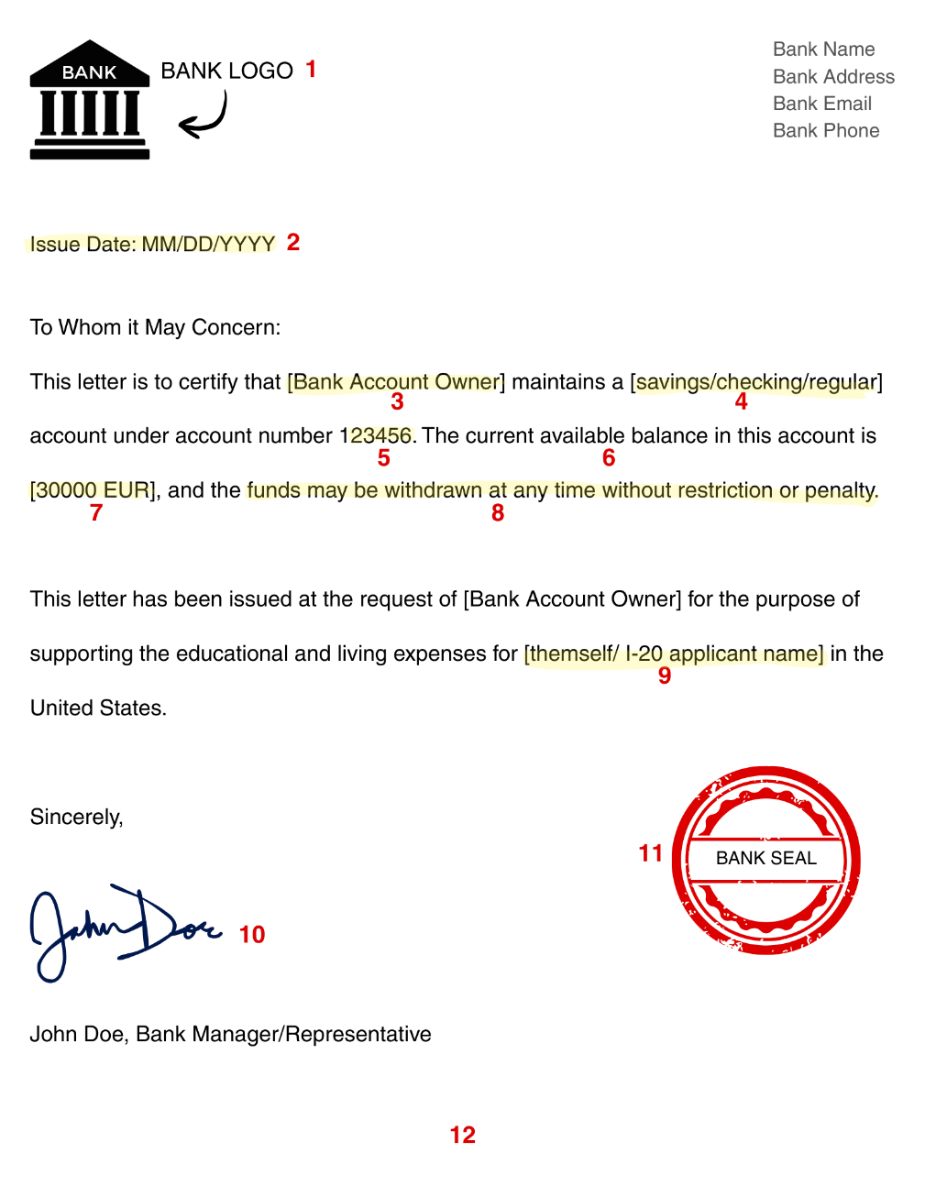
1. Official bank logo or letterhead
2. Date of letter: must be dated on or after August 1, 2025
3. Account holder name
4. Account type
5. Account number
6. Current account balance*
7. Currency
8. Confirmation that funds are liquid
9. I-20 applicant’s name
10. Signature of bank official
11. Bank seal
12. Letter written in English**
*If you do not wish to disclose the exact account balance, the letter can state “The current available balance is greater than [minimum amount required] [currency].”
**There are a few ways you can obtain an English-language financial document:
- Contact your bank directly and see if your bank's manager can issue an official/signed letter similar to the above sample.
- If option 1 is not possible, then you will need to obtain an official translation from a licensed translator. If you choose this route, you must also submit the paperwork for this service in addition to both translated and original documents.

IMPORTANT: PLEASE ENSURE you upload the Certificate of Finances form to the Certificate of Finances section of your I-20 task in your MyDCE Portal. Any supplementary financial documents, including bank statements and letters, should be uploaded to the Supporting Financial Documentation section of your I-20 task in your MyDCE Portal.

EXAMPLE LETTER FOR YOUR SCHOOL/COMPANY/ORGANIZATION/GOVERNMENT

[Print and sign on official letterhead]

[Enter address and contact information of school/company/organization here]
[Enter address and contact information of school/company/organization here]
[Enter address and contact information of school/company/organization here]

Harvard Division of Continuing Education
Harvard Summer School
51 Brattle Street
Cambridge, MA 02138

RE: Financial Support Letter

[Enter today’s date here]

To Whom It May Concern,

With this letter, [enter company/school/organization’s name here] declares financial support for [enter student’s full name here] to attend Harvard Summer School.

The financial support for [list items that will be covered such as academic fees, living expenses, books, supplies, insurance, program fees, etc.] will consist of at least [enter amount of USD here] for the duration of their studies: [enter student’s dates of study here].

Sincerely,

[Enter name of official from school/company/organization here]
[Enter title of official from school/company/organization here]
[Enter contact information of official from school/company/organization here]
[School/company/organization signature/stamp/seal goes in this blank space here]

